BREEAM USA In-Use International V6: Commercial

Draft Consultation Manual Feedback Form

Introduction
Thank you for taking the time to provide feedback on the draft manual of the next version of the scheme BREEAM USA In-Use V6 (BUIU V6); environmental performance assessment and certification scheme for existing non-domestic assets

The feedback form has two parts –

PART 1 Your background and Scope: asks about your background and role
PART 2 Technical Proposals: gives you the opportunity to provide your feedback on the technical proposals to allow BUIU to better respond to market drivers. Please ensure you fill in all fields before you put your comments, so we can correctly process your feedback.

For help to fill out the form please see HELP WITH THIS FORM section at the end of the document.

Please refer to the summary of the proposed changes and draft technical manual, available here:
Consultation

Enter your feedback below and return as a word document to BREEAMInUse@bregroup.com quoting “BUIU V6 feedback” in the subject line

Feedback

PART 1 - YOUR BACKGROUND AND SCOPE
- Are you replying on behalf of an organisation or as an individual?
Organisation
bre

- Please select the role that best describes you or your organisation in the context of this survey:
Architectural designer

Go to PART 2 - TECHNICAL PROPOSALS >>>

PART 2 - TECHNICAL PROPOSALS

Section asset
Issue: tra 05
Issue Section: value
Id Reference: E.g criterion 1
Feedback Category: dddddeeedd
butgwew.
Section Select an item.
Issue: Select BREEAM Category Select issue ref number
Issue Section: Select an item
Id Reference: e.g. crit 1.a.
Feedback Category: Choose a category
butgwew.
Section Select an item.
Issue: Select BREEAM Category Select issue ref number
Issue Section: Select an item
Id Reference: e.g. crit 1.a.
Feedback Category: Choose a category
butgwew.
Section Select an item.
Issue: Select BREEAM Category Select issue ref number
Issue Section: Select an item
Id Reference: e.g. crit 1.a.
Feedback Category: Choose a category
butgwew.
Section Select an item.
Issue: Select BREEAM Category Select issue ref number
Issue Section: Select an item
Id Reference: e.g. crit 1.a.
Feedback Category: Choose a category
butgwew.
Add as many feedback items above as you need for each area and topic you wish to provide feedback on.
To add rows, click the + icon at the side of the table.

Thank you for your feedback.

Please return this form as word document to BREEAMInUse@bregroup.com quoting “BUIU V6 feedback” in the subject line

Help with this form
- Choose a Section from dropdown
- Choose BREEAM Category from dropdown
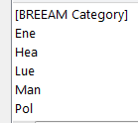
- Choose issue ref from drop down

- Choose an item from drop down
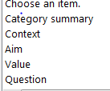

- Choose a Feedback category
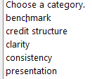
Or where a predefined option doesn’t suit your comment enter a category into the category field
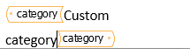
- Write a comment.

- To add rows, click the + icon at the side of the table
Or right click on the table and choose insert / delete feedback
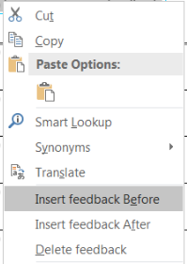
- Please return this form to BREEAMInUse@bregroup.com quoting “BUIU V6 feedback” in the subject line
Go to Share > Email > Send As Attachment
