BREEAM In-Use International V6: Commercial

Draft Consultation Manual Feedback Form

Introduction
Thank you for taking the time to provide feedback on the draft manual of the next version of the scheme BREEAM In-Use V6 (BIU V6); environmental performance assessment and certification scheme for existing non-domestic assets

The feedback form has two parts –

PART 1 Your background and Scope: asks about your background and role
PART 2 Technical Proposals: gives you the opportunity to provide your feedback on the technical proposals to allow BIU to better respond to market drivers. Please ensure you fill in all fields before you put your comments, so we can correctly process your feedback.

For help to fill out the form please see HELP WITH THIS FORM section at the end of the document.

Please refer to the summary of the proposed changes and draft technical manual, available here:
Consultation

Enter your feedback below and return as a word document to BREEAMInUse@bregroup.com quoting “BIU V6 feedback” form in the subject line

Feedback

PART 1 - YOUR BACKGROUND AND SCOPE
- Are you replying on behalf of an organisation or as an individual?
Choose an item.
Please enter Company Name if you’re responding on behalf of your organisation

- Please select the role that best describes you or your organisation in the context of this survey:
Choose a role

Go to PART 2 - TECHNICAL PROPOSALS >>>

PART 2 - TECHNICAL PROPOSALS

Section Select an item.
Issue: Select BREEAM Category Select issue ref number
Issue Section: Select an item
Id Reference: e.g. crit 1.a.
Feedback Category: Choose a category
Click or tap here to enter your feedback.
Section Select an item.
Issue: Select BREEAM Category Select issue ref number
Issue Section: Select an item
Id Reference: e.g. crit 1.a.
Feedback Category: Choose a category
Click or tap here to enter your feedback.
Add as many feedback items above as you need for each area and topic you wish to provide feedback on.
To add rows, click the + icon at the side of the table.

Thank you for your feedback.

Please return this form as word document to BREEAMInUse@bregroup.com quoting “BIU V6 feedback” in the subject line

Help with this form
- Choose a Section from dropdown
- Choose BREEAM Category from dropdown
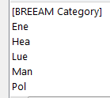
- Choose issue ref from drop down

- Choose an item from drop down
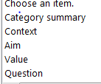

- Choose a Feedback category
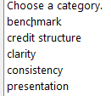
Or where a predefined option doesn’t suit your comment enter a category into the category field
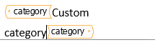
- Write a comment.

- To add rows, click the + icon at the side of the table
Or right click on the table and choose insert / delete feedback
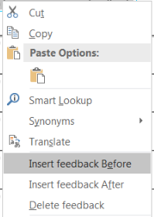
- Please return this form to BREEAMInUse@bregroup.com quoting “BIU V6 feedback” in the subject line
Go to Share > Email > Send As Attachment
